

**Indian Institute of Remote Sensing**

**PROJECT REPORT-2024**

**Investigation of intensity and frequency of heat waves over Gujarat region**

**Submitted to:**

**Dr. Charu Singh**

(Scientist/Engineer -SF)

(Marine and Atmospheric Sciences Group) IIRS – Dehradun

**Report by**

**Viraj Hirpara**

**Smit Bhuva**

(M.Sc. Agriculture Analytics, DAIICT)

Dared: April 23, 2024

**CERTIFICATE**

This is to certify that Mr. Viraj Hirpara & Smitkumar Bhuva have carried out the Post-Graduate project entitled-**Investigation of Intensity and Frequency Heat Waves over Gujarat Region.**it is an original record of work for the partial fulfilment of Post-Graduate in Agriculture Analytics. The project was carried out under the supervision of Dr. Charu Singh, Scientist/Engineer-SD, Marine and Atmospheric Sciences Department, Indian Institute of Remote Sensing (IIRS), Indian Space Research Organization (ISRO), and Dehradun.

Dr. N. R Patel

Scientist, HoD

Agriculture and Soil Department

DAIICT Program Coordinator

Dr. Charu Singh

Scientist – SF

Marine and Atmospheric Science Department

Project Guide

.

**DISCLAIMER**

This document describes the work carried out as part of our course MSc. Agriculture Analytics. The work is carried out at the Indian Institute of Remote Sensing, ISRO, Dehradun. All views and opinions expressed therein remain the sole responsibility of the author and do not necessarily represent those of the Institute.

## DECLARATION

We hereby declare that the work presented here entitled *“*Study of Heatwave events using previous year data analysis of duration, intensity and frequency*”* has been carried out by us and further declare that it has not been submitted earlier in part or in whole to any University or Institution for the award of any Degree or Diploma. The work embodied here has been carried out at the Indian Institute of Remote Sensing (IIRS), ISRO, Dehradun under the supervision of Dr. Charu Singh, Scientist/Engineer- ‘SF’, Marine and Atmospheric Sciences Group, IIRS. The extent of information derived from the existing literature has been indicated in the body of the report at appropriate places giving the source of information.

Viraj Hirpara,

Smit Bhuva

Place: Dehradun

Date: 22.04.2024

**Acknowledgement**

We would like to express our sincere gratitude to Dr Charu Singh, Scientist/engineer-‘SF’, Marine and Atmospheric Sciences group at Indian Institute of Remote Sensing (IIRS), ISRO Dehradun for her valuable guidance and support throughout this project. Her insights and expertise have been invaluable in shaping the direction of this study.

We would also like to extend our thanks to Dr. N.R. Patel for giving us this opportunity to work with a scientist who has expertise in this type of study. Also thankful to platforms like MODIS for providing us free dataset for the study, without that our study would not be possible. Thank you all for your contribution.

**ABSTRACT**

Using remotely sensed MODIS Land Surface Temperature data, an analysis of characteristics of Heat Waves or extreme temperature events during the pre-monsoon season (March, April and May months) has been conducted over Gujarat Region for the period of 2003-2023. In order to identify the extreme events, a histogram analysis is done which shows that the Heat Waves can be considered when the Land Surface Temperature is above the 95th percentile of the Daily Mean Temperature.

To further calculate the frequency, duration and intensity of the extreme events, a heat index is calculated using the Long Term Mean and Daily Mean Temperature The detailed analysis have been carried out over Gujarat Region as well as each and every individual districts to analyze the temperature variation Within the year as well as inter annual variability. It has been noted from the analysis that Kachchh, Ahmedabad, Sabar Kantha, Rajkot and Porbandar are the region which are severely hit by Heatwaves every year. The trend analysis doesn’t show any significant trends in the number of heatwave events over the years but a substantial relationship between the number of events of heatwaves in Gujarat and EL-NINO conditions in the Pacific region.

2004, 2005 and 2015 witnessed maximum number of heatwaves over Gujarat region.

**Keywords**: Extreme events, Heat Index, MODIS, long term mean, Gujarat region

**Table of content**

1. Introduction
   1. Background
      1. Geography of Gujarat
      2. Heatwaves in Gujarat
      3. Impact on crop growth
   2. Research Identification
      1. Research Objective
      2. Research Question
2. Literature review
3. Study area
4. Dataset and methodology
   1. Satellite data used
   2. Software used
   3. Research methodology
      1. Data Download
      2. Data Preprocessing
      3. Statistical Analysis: Extreme events and their trends
5. Result and discussion
   1. Histogram analysis
      1. Calculation of heat index
         1. Yearly heat index plots for Gujarat
      2. **Identification of heatwaves, their duration, intensity and frequency**
6. Appendices

**CHAPTER 1.**

**INTRODUCTION**

* 1. **Background**

Global climate change is inevitable. Climate Change reasons increase the mean average surface temperature over a region. We are already witnessing extreme weather events. Heat waves are projected to increase in number, intensity and duration over most land areas in the 21st century. It is a period of abnormally high temperatures, more than the normal maximum temperature that occurs during the pre-monsoon (March to May) summer season. Heat -waves typically occur between March to May, and in some rare cases even extend till June. On average, 5-6 heat wave events occur every year over different parts of the country.

Extreme heat can lead to dangerous, even deadly, health consequences, including heat stress and heat stroke. The impact of rising temperatures and increasing frequency, duration and intensity of hot spells pose challenges to human safety and sustainability. This unusual and uncomfortable hot weather can impact human and animal health. Heatwave is also called a “silent disaster” as they develop slowly and kill and injure humans and animals. Higher daily peak temperatures of longer duration and more intense heat waves are becoming increasingly frequent globally due to climate change.

**1.1.1 Geography of Gujarat**

The State of Gujarat was formed on 1st May 1960. The total geographical area of the state is 196,024 square kilometres. It stretches from 20-6' N to 24-42' N latitude and from 68-10'E to 74-28' E longitude. As per the 2011 census, the population of the State comes to nearly 6.04 crores, which is around 5% of the population of India. The state of Gujarat comprises of 33 districts, 252 Talukas, 8 Municipal Corporations (Ahmadabad, Surat, Vadodara, Rajkot, Bhavnagar, Jamnagar, Junagadh and Gandhinagar), 159 Municipalities and approx. 18000 Villages.

The maximum temperature ranges between 26°C and 45°C while the minimum temperature varies between 10.8°C and 27.4°C. Gujarat’s agro-climate is very heterogeneous and constitutes about 20 per cent of arid and 9 per cent of semi-arid areas of the country. A vast area of Saurashtra Kutch and North Gujarat falls under Arid to Semi-arid. It comprises low and erratic rainfall. The winter is mild cold, whereas summer is hot.

**1.1.2 Heat Wave in Gujarat**

In the last decade, due to rapid climate change, urbanization and rapid industrialization effects, we felt the effects of the Heat Wave almost every year with high intensity and frequent episodes. With heat wave affecting conditions from 2015-2018, the number of deaths reported across the state were 58, 446, 463, and 775 respectively which is showing an increasing trend of the deaths and pays emphasis on prevention of mitigation of the same. In May 2010, Ahmedabad faced a deadly heat wave with peak temperatures of over 46°C causing a spike in illness and death. Over 4,462 (all-cause) deaths occurred in May 2010, comprising an excess of 1,344 (all-cause) deaths, an estimated 43.1% increase when compared to the average of the same month in 2009 & 2011. Following this, the Indian Institute of Public Health Gandhinagar (IIPHG) supported by the Natural Resources Defense Council (NRDC) helped the Ahmedabad Municipal Corporation (AMC) to launch the Heat Action Plan (HAP) in Ahmedabad in 2013. This was the first such preparedness plan for extreme heat events in South Asia. A study in 2018 evaluated the effectiveness of the Ahmedabad HAP before and after implementation. The study found that an estimated 2,380 deaths were avoided in the post-HAP period. The findings suggest that the Ahmedabad HAP protected health against mortality associated with extreme heat.

**1.1.3 Impact on Crop Growth**

The impact of a heat wave on agriculture can be direct (physical damage to crops, animals and trees caused by the extreme hydro-meteorological events), or indirect (loss of potential production owing to disturbed flow of goods and services, lost production capacities, and increased costs of production).

Heatwave impacts crop growth and development at different levels like soil moisture uptake, root and shoot growth, photosynthesis, respiration, plant water uptake and final yield. Heatwave competes for soil moisture by hastened evaporation, leaving almost no moisture for uptake by plants. Heatwave also causes overall environmental degradation, which is a major factor contributing to the vulnerability of agriculture, forestry and rangelands to heat waves.

* 1. **Research Identification**

Higher daily peak temperatures and longer, intense heat waves are becoming increasingly frequent globally due to climate change. India, too, witnesses increased instances of heat waves, more intense and longer duration with every passing year which has a devastating impact on human life. Prolonged severe heat wave conditions may cause serious problems to water supply, cause moisture stress in the soil and adversely affect agriculture. There is a need to analyze the duration, frequency and intensity of the extreme events.

**1.2.1 Research Objectives**

* To find the Heat index and understand the characteristics of extreme events – duration, frequency and intensity.
* To Analyse the Pattern and Trend of the previous 33 years' data over Gujarat region.
  + 1. **Research Questions**
* What are the characteristics of extreme events – duration, frequency and intensity over the past 33 years over the Gujarat region?

**CHAPTER 2.**

**LITERATURE REVIEW**

HW is the least explored and hazardous natural extreme weather event as compared to other hydro-meteorological disaster events, particularly in India. The global warming and climate change effects on HW occurrence are seen in the form of increasing trends of duration, intensity and frequency. The recent past and future characteristics of HW are based on the physiology of the region in India. Based on the IMD HW criterion in a hilly plain and coastal region, HW average duration, HW maximum duration, HW days and HW events have been increasing in spatial extent as well as in temporal extent over the larger parts of India. (Rani Devi, K C Gouda & Smrutishree Lenka, 2023).

HWs were found to be significantly associated with increased mortality. Despite the recent high-impact mega-HWs and intense mediatisation, the population does not perceive these events as a serious threat to human life, especially for vulnerable categories (children, elderly, and persons with pre-existent diseases). This may happen because of the lack of sudden dramatic manifestation of these events as in the case of hurricanes and floods. To prevent the harmful effects of HW on human health some measures can be effective. These consist of wearing lightweight clothes during hot episodes, rehydration, reducing excess weight, rigorous emergency planning, heat health warning systems, and reduction of heat stress in outdoor or indoor environments.(Adrian Piticar, Sorin Chevel, 2019).

The LULC/urbanization-induced surface temperature rise has become a common phenomenon all across the globe though the rate of change depends upon several external factors such as latitude, forest cover, soil type, mitigation practices etc. It may be noted that LULC change has been attributed to increased surface temperatures in Eastern China, the USA, Europe, and India. Despite varied locations, it is observed that the rate of increase in most of these places is ~0.1 °C/decade which is comparable to that of our study. Though LULC-induced warming has emerged over this region only in the past couple of decades, we find that in terms of LULC-induced temperature rise, Eastern India is no less than any other developed region in the world. (Partha Pratim Gogoi, V. Vinoj, D. Swain, G. Roberts, J. Dash & S. Tripathy).

A heat wave in March 2022 is quite clearly visible in the thermal infrared channel of INSAT-3D. The linear fit to the LST and Air Temperature indicates the increasing trend in an urban region. However, the trend in the cropland region is quite interesting to analyze since the air temp slightly decreases over time in contrast to the increasing trend in LST. This aspect may be attributed to the dynamic behaviour of land cover changes in cropland degradation near urban regions which may, in turn, lead to a different manifestation of results in the cropland region. (Parthkumar N. Parmar, Mehul R. Pandya, Jalpesh A. Daves, Hasmukh K. Varchand, Himanshu J. Trivedi, 2022).

The development of a generic index for HW requires special correction parameters or a value or a relation concerning the region. For this purpose, study on a mass level is required and countries need to be selected region-wise and based on meteorological variations so that every perspective of diverse variation in weather can be included. This study summarizes the basic ideas about HW and HI so that this knowledge can provide a platform to develop or modify the existing definitions and formulas so that necessary steps can be taken to minimize the hazardous effects of extreme events like HW. There are several definitions for HW, but for HI, Steadman’s equation is still used as a generic equation. There is a need to develop separate HI equations as per different geographical and climatic conditions. ([Amit Awasthi](https://link.springer.com/article/10.1007/s00704-021-03854-z#auth-Amit-Awasthi-Aff1), [Kirti Vishwakarma](https://link.springer.com/article/10.1007/s00704-021-03854-z#auth-Kirti-Vishwakarma-Aff2) & [Kanhu Charan Pattnayak](https://link.springer.com/article/10.1007/s00704-021-03854-z#auth-Kanhu_Charan-Pattnayak-Aff3), 2021)

Heat Wave impact gets aggravated by a variety of meteorological as well as socio-economical parameters. Efforts are going on to explore the full array of factors that drive heat stress, including possible synergistic effects of demography, society, economies, pollution etc. which may vary from place to place. Also, the factors that are understood to be affecting heat wave events are changing with time, making it more difficult to have a universal definition and thresholds to assess the impact of Heat Wave events. In this study, an attempt is made to quantify the impact of different meteorological parameters in aggravating heat wave impacts and thereby leading to heat wave hazard zonation of the country. In a nutshell, the cumulative heat wave hazard impact is inferred to be maximum over Bihar, Jharkhand, West Bengal, Parts of Odisha and parts of Northeast India, over some parts of Bundelkhand region and neighbourhood, over northern parts of south peninsular India and some parts over southern parts of Madhya Maharashtra and southernmost areas of Tamilnadu during March to June and also over Jammu region during April and May and over Gujarat and Saurashtra region during May and June. ( [Akhil Srivastava](https://www.nature.com/articles/s41598-022-24065-0#auth-Akhil-Srivastava-Aff1), [M. Mohapatra](https://www.nature.com/articles/s41598-022-24065-0#auth-M_-Mohapatra-Aff1) & [Naresh Kumar](https://www.nature.com/articles/s41598-022-24065-0#auth-Naresh-Kumar-Aff1), 2022).

combined heat wave index (CHI), by combining different heat wave parameters, like magnitude, occurrence, and extent. The varying values of these parameters have different implications on the

overall heat wave characteristics. Hence, a methodology has been developed to combine all these three parameters in quantifying the heat wave. It was observed that the CHI was able to properly characterise and quantify the heat wave conditions across different parts of the Indian mainland; moreover, its capability to address the inter-annual variations in heat waves was also evident. The study revealed that persistent heat waves with higher magnitude were frequent over northwestern India, covering Rajasthan, Punjab Haryana, and Madhya Pradesh, whereas the values of heat wave magnitude and frequency were quite lower over eastern India. The long-term trend analysis showed that the trends of heat waves were increasing in parts of north-western India and some parts of eastern India, whereas it was lower in Uttar Pradesh, Bihar, Chhattisgarh, Telangana, and Andhra Pradesh. The present study revealed that May had maximum

contribution in seasonal heat waves over parts of northwestern and Central India, whereas it was June in Punjab, Haryana, and western Rajasthan. It was interesting to find that the contribution of March was maximum over the peninsular India. The decadal changes in heat wave characteristics were evident; however, persistent higher heat waves were also observed over parts of northwestern India and the Indo-Gangetic Plain. The varying significant trends in heat waves over different parts of the Indian mainland may be due to alterations in the amount and distribution of pre-monsoon rainfall. Moreover, the studies on climate change and associated impacts on global circulations, like southern oscillation and Indian Ocean dipole, along with the increasing aerosol due to crop residue burning need to be attempted before drawing any conclusions on causes of varying trends in heat waves over parts of the country. (Prabir Kumar Das, Ushashi Podder, Rituparna Das, Chandrasekar Kamalakannan, Goru Srinivasa Rao, Soumya Bandyopadhyay & Uday Raj, 2020).

The HW criteria, it is important to understand the observed spatial distribution of extreme temperatures. depicts the observed climatology of Tmax values during March, April, and May for the period 1981–2010, and represents the climatological extreme (95th percentile values) of Tmax for the same period. It is observed that during March, April, and May, Tmax values of more than 36 °C exist over northwest, central and parts of southeastern regions. Tmax values are less over the northeastern and southwestern parts of the country. than over northwest, central, east and southeast coastal parts, the minimum 95th percentile value of Tmax is 36 °C. Hence, based on these observed distribution of Tmax values, we have defined a HW criterion (please refer to Methods section for more details about the proposed HW criterion) considering the actual (36 °C), departure from normal (3.5 °C) and 95th percentile value of Tmax in gridded data. Based on the proposed HW criteria, the average number of HW days during March, April, and May over the period 1981–2017 and 2001–2017 have been calculated and placed. the north-west, central and south-eastern parts of India are the HW-prone regions, having more than 4 HW days/year during MAMJ. It is interesting that in recent years, the southeast coastal region has become more vulnerable to HW events. Many places in northwest and southeast coastal regions have more than 8 HW days per season. Therefore, it is found that northwest, central and southeast coastal regions are mostly affected by the severe HW days in the summer season. On the other hand, the northeastern and southwestern parts of the country are less vulnerable to HWs.([Raju Mandal](https://www.nature.com/articles/s41598-019-45430-6#auth-Raju-Mandal-Aff1-Aff2), [Susmitha Joseph](https://www.nature.com/articles/s41598-019-45430-6#auth-Susmitha-Joseph-Aff1), [A. K. Sahai](https://www.nature.com/articles/s41598-019-45430-6#auth-A__K_-Sahai-Aff1), [R. Phani](https://www.nature.com/articles/s41598-019-45430-6#auth-R_-Phani-Aff1-Aff3), [A. Dey](https://www.nature.com/articles/s41598-019-45430-6#auth-A_-Dey-Aff1), [R. Chattopadhyay](https://www.nature.com/articles/s41598-019-45430-6#auth-R_-Chattopadhyay-Aff1) &  [D. R. Pattanaik](https://www.nature.com/articles/s41598-019-45430-6#auth-D__R_-Pattanaik-Aff4), 2019).

**CHAPTER 3.**

**STUDY AREA**

* The study area is confined to Gujrat Region of India extending from 68º W-74ºE and 24ºN-20ºS.

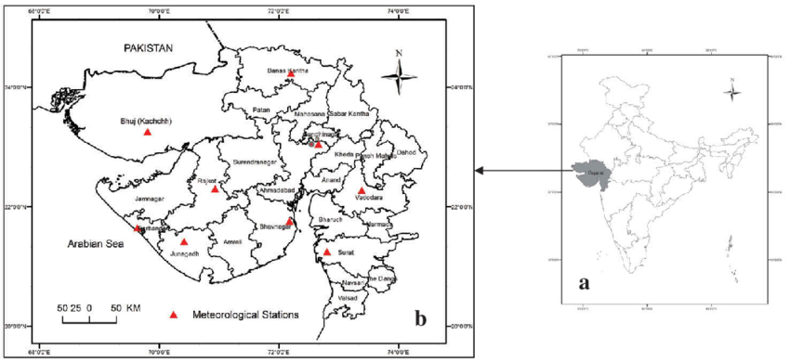

Figure 3.1 – Study Area

**Study Area:** Gujarat is the fifth largest state by size and has the longest coastline in the country, located in western India. The Major landforms of Gujarat include Mountains, Hills, plateaus, and plains, as well as weather is typically hot, and cold and dries in summer and winter season.

IMD has adopted the following three categories:

1. First category - When the normal maximum temperature of a station is less than or equal to 40 °C, heat wave (HW)may be considered, if the maximum temperature departure from normal is 5 °C to 6 °C and severe heat wave (SHW)may be considered if the departure from normal is 7 °C or more.
2. Second category - When the normal maximum temperature of a station is more than 40 °C then heat wave(HW) may be considered if the maximum temperature departure from normal is 4 °C to 5 °C and severe heatwave if the departure from normal is 6 °C or more.
3. Third category - When the actual maximum temperature remains 45 °C or more irrespective of normal maximum temperature, a heat wave should be declared**.**

**EXTREME HIGH-TEMPERATURE CONDITIONS OVER GUJARAT:**

* Patan District of the northern region recorded 45.4 degrees Celsius on 11th May 2023, said officials of the India Meteorological Department (IMD).
* Ahmadabad, Deesa and Gandhinagar recorded the highest day temperature of 48 Degrees Celsius on 18th May, 2016 breaking its record of the last 100 years of 47.8 Degrees Celsius as per the IMD record of 27th May, 2016.
* In Gujarat, multiple districts have recorded daytime mercuries higher than normal today, but Rajkot (39.3°C), Kutch (38°C), Ahmedabad (37.3°C), Amreli (36.6°C), Bhavnagar (36.6°C) and Porbandar (37.5°C) have recorded especially high temperature already on 20 March 2024.
* The[maximum temperature crossed the 40 degrees Celsius mark](https://www.indiatoday.in/cities/delhi/story/delhi-ncr-sizzles-at-40-degrees-celsius-severe-heatwave-likely-in-next-48-hours-1930778-2022-03-29) at several locations, including Surendranagar (44.4 degrees Celsius), Bhuj (43.4), Keshod (43.7), Amreli (43.4), Deesa (43.4), Ahmedabad (43.2), Rajkot (43.1) and Gandhinagar (43) on 10 April 2022.
* In Gujarat, the temperature rose above 43 degrees including Junagadh (44.6), Amreli (44.0), Rajkot (43.8), Vadodara (43.8), Ahmedabad (43.7), Deesa (43.7), Chhotaudepur (43,7), Panchmahal KVK (43.5), Porbandar (43.5), Surat KVK (43.5), Gandhinagar (43.5) and Bhuj (43.4) on 11 May 2023.

**CHAPTER 4.**

**DATASET AND METHODOLOGY**

Satellite data of Land Surface Temperature from the MODIS dataset is utilized to analyze the Heatwave occurrence over Gujarat region.

**Why LST?**

Characteristics and Behavior of Land Surface Temperature resemble the characteristics and behaviour of 2m Air Temperature of the same area/region. Although there is always 4⁰ to 8⁰ difference between them; hence LST will mostly have higher values than 2m Air Temperature as the Land surface heats more rapidly than air. (Heat Wave Study using Satellite LST and Air Temperature Data over Gujarat Region – Parmar Parth Kumar; Link –([Reference Report](https://www.google.com/url?sa=t&source=web&rct=j&opi=89978449&url=https://www.ursi.org/proceedings/2022/RCRS2022/papers/SummaryPaperParmarParthkumar.pdf.pdf&ved=2ahUKEwjonN7XsNCFAxU8cGwGHbESBI0QFnoECCsQAQ&usg=AOvVaw27orb8L0dNd87lj15SZrdF)))

**4.1 Satellite Data Used:**

MODIS Terra Land Surface Temperature and Emissivity daily global 1km (MOD11A1 v061) product provides valuable daily data for Earth scientists. This global dataset offers detailed measurements at a resolution of 1 kilometre, allowing researchers to analyze variations in land surface temperature and emissivity across the entire planet. This dataset can be accessed via the Landsat website as well as Google Earth Engine.

**4.2 Software used:**

i) Google Earth Engine: A Software as a Service that provides satellite datasets as well processing platform for the dataset via cloud computers.

ii) Microsoft Excel: A spreadsheet software developed by Microsoft that helps in organizing, manipulating data, performing arithmetic operations etc.

iii) Jetbrains PyCharm IDE: An Integrated Development Environment developed by Jetbrains for Data scientists and Python developers.

**4.3 Research Methodology:**

This project aims to identify extreme temperature events in Gujarat along with their trends with the help of Heat Index and temperature anomaly calculations from the long-term mean. The diagram, given here; represents the workflow we worked on.

Figure 4.1 : Workflow of Project

**4.3.1 Data Download:**

Google Earth Engine entirely takes input as JavaScript code and returns output in desired format. Here, we derived output in csv format as one file for March, April and May month of each year and after pre-processing that data, we used it directly to analyze it. Here, I am sharing Earth Engine code snippet:

/** Start of imports. If edited, may not auto-convert in the playground. **/

var table = ee.FeatureCollection("projects/ee-smitpatel2745/assets/GJ_ADM");

/** End of imports. If edited, may not auto-convert in the playground. **/

// Define the region of Gujarat

var gujarat = ee.FeatureCollection("FAO/GAUL/2015/level1")

.filter(ee.Filter.eq('ADM1_NAME', 'Gujarat'));

// Define the districts within Gujarat

var districts = ee.FeatureCollection("FAO/GAUL/2015/level2")

.filterBounds(gujarat);

// Load the ERA5-Land dataset for temperature

var era5 = ee.ImageCollection("MODIS/061/MOD11A1")

.select('LST_Day_1km')

.filterDate('2002-03-01', '2002-05-31')

.filterBounds(districts) // Filter to the extent of districts

.map(function(image) {

return image.clip(districts); // Clip images to district boundaries

});

// Function to aggregate temperature data for each district and date

function aggregateTemperature(image) {

var date = ee.Date(image.get('system:time_start')).format("YYYY-MM-dd");

var districtTemperature = image.reduceRegions({

collection: districts,

reducer: ee.Reducer.mean(),

// scale: 1000 // Adjust as needed

});

return districtTemperature.map(function(feature) {

return feature.set('date', date);

});

}

// Aggregate data by district and date

var districtDailyTemperature = era5.map(aggregateTemperature).flatten();

// Export the data to Google Drive as a CSV file

Export.table.toDrive({

collection: districtDailyTemperature,

description: 'GJ_LST_Daily_2002',

folder: "Heatwave_analysis",

fileFormat: 'CSV' // Export as CSV file

});

**4.3.2 Data Preprocessing:**

This process included data cleaning for unnecessary data like geometry, organizing data into one file etc. done in Microsoft excel and filling of null values and NaN values is done using Python Programming

**4.3.3** **Statistical Analysis: Extreme events and their trends**

Temperature extremes are usually identified relative to the average weather of the region of study. According to World Meteorological Organization, analysis related to weather elements that are measured on daily basis.

1. Histogram analysis: Histograms are plotted for Land Surface Temperature as well as Heat index. 95th Percentile is taken as threshold value for heatwave detection
2. Heat index calculation by using Long Term Mean (TLT) of each month (MAM months – 92 days for 21 years (2003-2023)) and standard deviation of the long-term mean.

Long term mean is calculated by taking the average of daily mean temperature of each day for 21 years

1. Duration intensity and frequency of extreme events are calculated by taking a threshold value, we took 0.8 as threshold anomaly. Here, (Daily mean temperature – long term mean of that day) is the anomaly of temperature. We took consecutive 5 days with anomaly more than 0.8 as heatwave events and calculated it for all 25 districts of Gujarat and for all 21 years.

**CHAPTER 5.**

**RESULT AND DISCUSSION**

This chapter discusses the result obtained from the project work analysis. The objective was to identify heatwave events, it’s intensity and frequency over Gujarat region.

**5.1 Histogram Analysis:**

Histogram provides an effective way to understand the temperature characteristics. The Figure 5.1 shows the histogram of whole Gujarat region for temperature anomalies and figure 5.2 shows heat index histogram for Kachchh and Ahmedabad along with mean temperature histograms. They convey how a particular temperature or anomaly point occurs.

The frequency of lower and higher temperature events are less as can be seen in histograms The extreme temperature events are at the end of the histogram in moth studies.

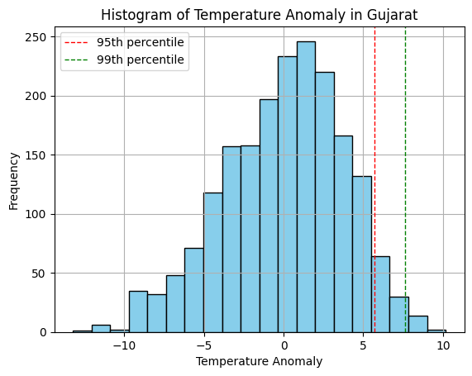

Figure 5.1 : Histogram showing Temperature anomaly over Gujarat

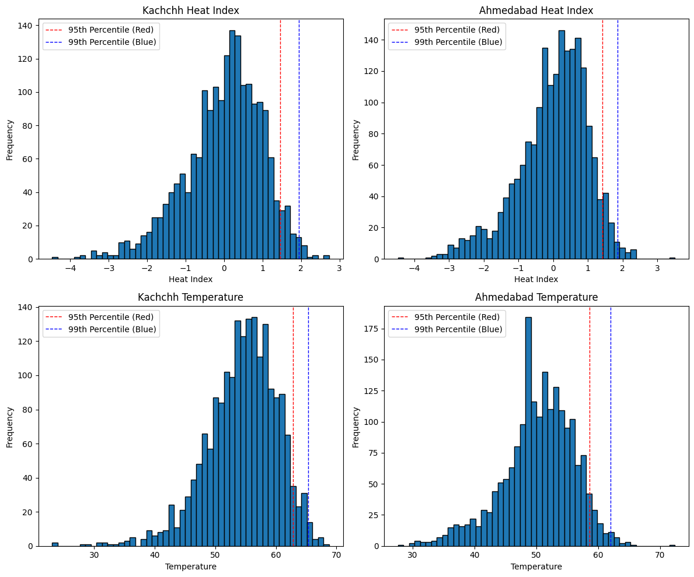Figure 5.2 : Histogram of Ahmedabad and Kachchh Districts for Heat index and Temperature

As the extreme events are rare, to identify the threshold, we used 95th percentile. The percentile is calculated for all the districts of Gujarat state.

Figure 5.3 shows the trend of daily average LST over 21 years (2003-2023) for Kachchh, Ahmedabad, Rajkot, Bhavnagar, Amreli and Porbandar; total 6 districts which are among hottest cities in Gujarat.

This figure shows although there is no linear increment in temperature aver years, we can clearly say that every year, the month of April is dominated by majority of heatwave events all over Gujarat.

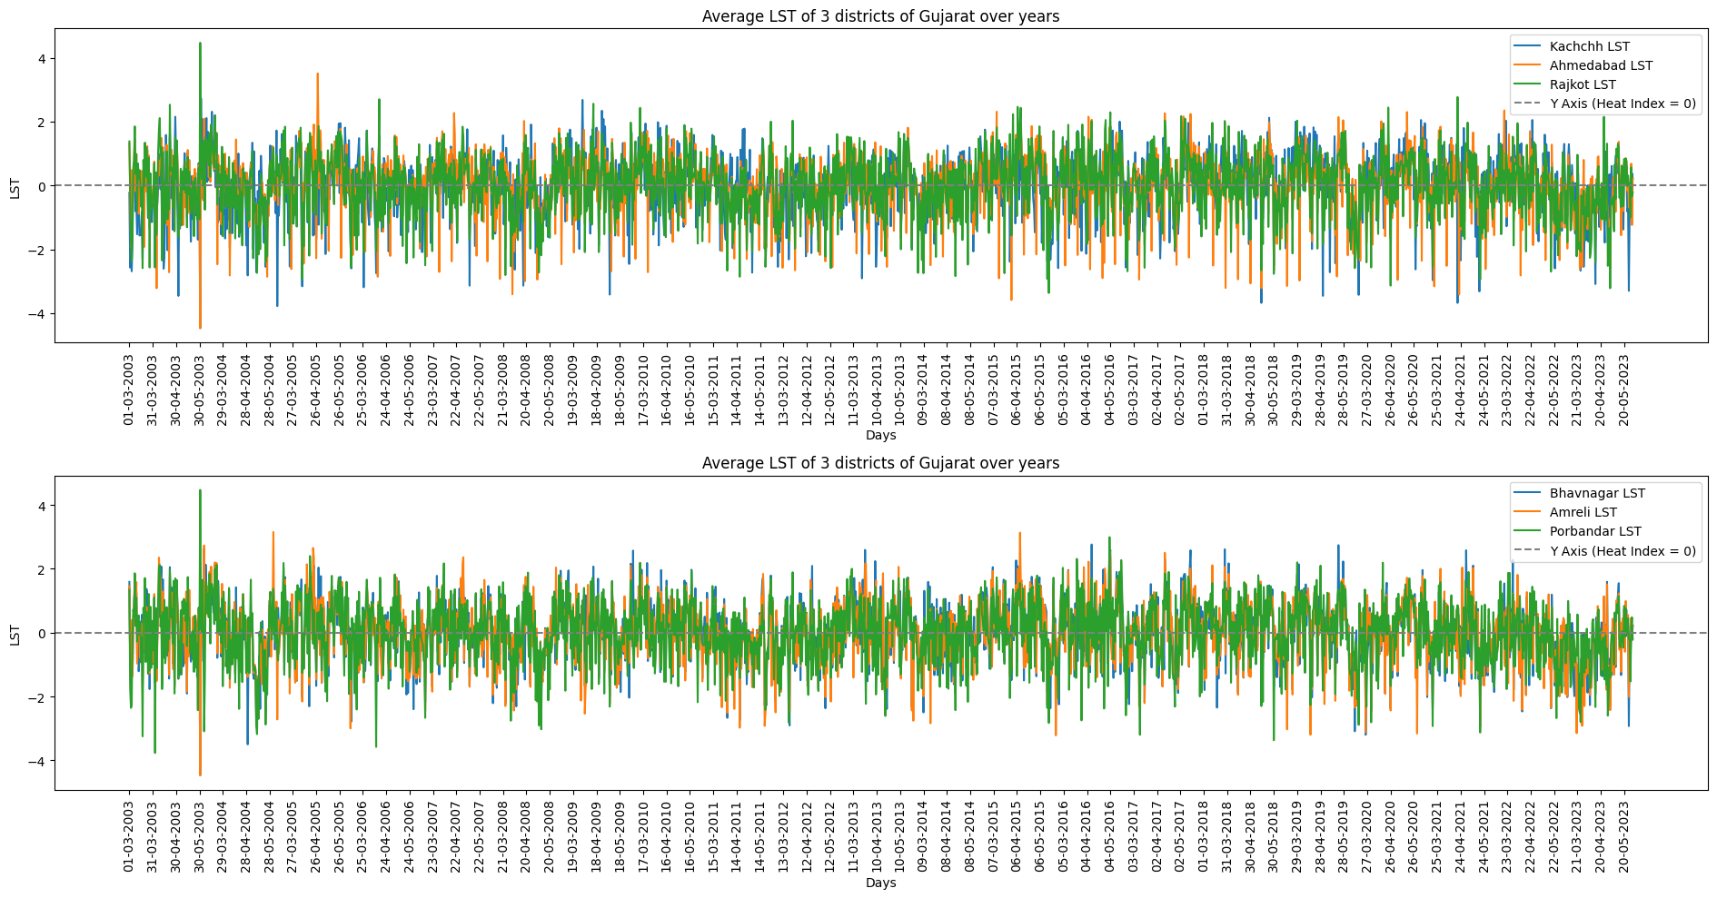Figure 5.3: Trend of daily LST of Gujarat for 21 years

**5.1.1 Calculation of Heat index:**

The heat index is calculate using daily mean temperature of each day of MAM months for 21 years: 2003 to 2023 and mean of each day for 21 years which can be called as long term mean and standard deviation of the long-term means

Formula:

**5.1.1.1 Yearly heat index plots for Gujarat**

We plotted graphs for heat index for 2003, 2013 and 2023, which are shown here as figure 5.4, 5.5 and 5.6.

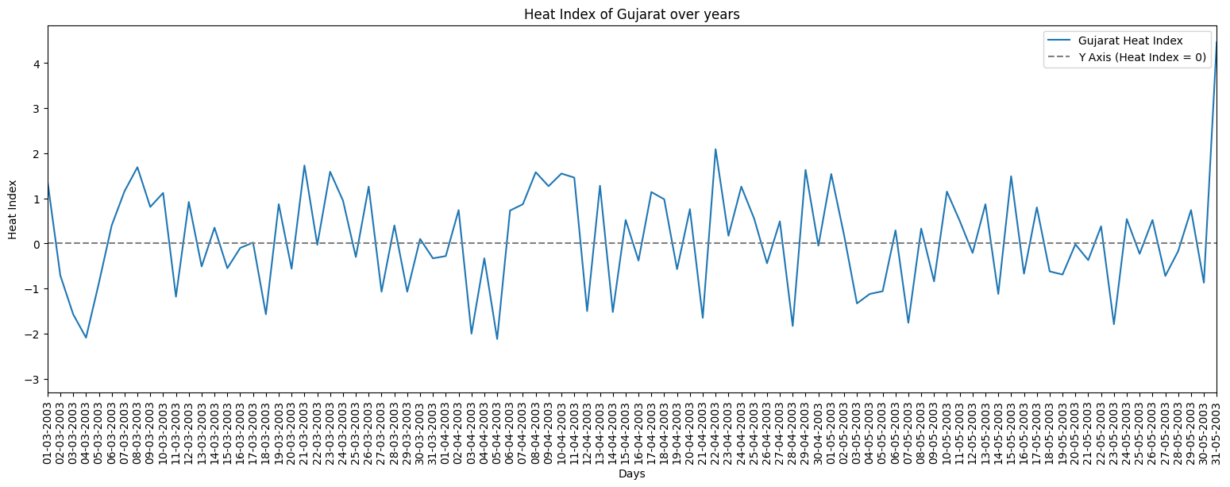Figure 5.4: Heat index of Gujarat for 2003

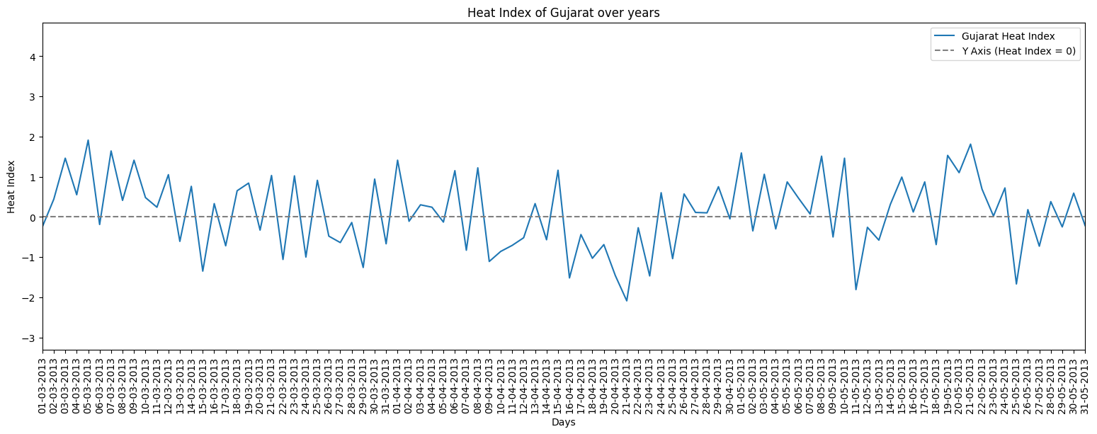

Figure 5.5: Heat index of Gujarat for 2013

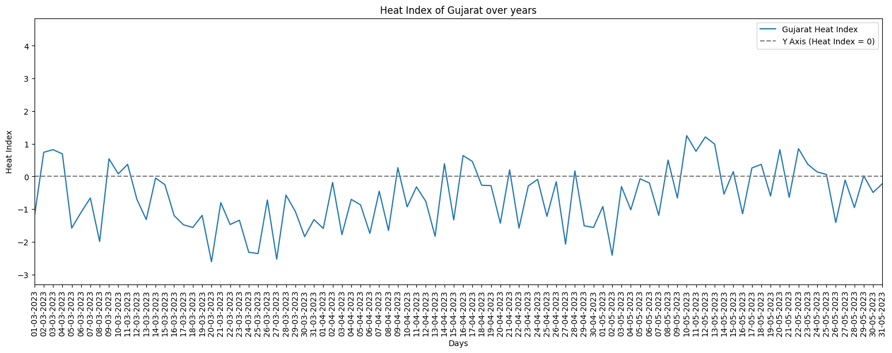

Figure 5.6: Heat index of Gujarat for 2023

Here, according to graph, we can say that there is lots of variation in het index of Gujarat over years. Highest peak denotes highest possibility of Heatwaves and vice-versa. Here, Heat Index also says same that every year, April month is prone to maximum heatwaves.

**5.1.2 Identification of heatwaves, their duration, intensity and frequency**

The extreme weather events i.e. Heatwaves, their duration, intensity and frequency are calculated by using Heat Index and anomaly values. We used Heat index as 0.3 and anomaly as 0.8 as threshold values. The days which have more temperature than threshold values and continue for more than 3 days are considered as Heatwave events.

Furthermore, some of the district have rare heatwave events in which, they got heatwave events more than 12 times a year. Those Districts are Banas Kantha(2015), Gandhinagar(2004), Jamnagar(2005), Junagadh(2005, 2015), Mahesana(2004), Panchmahal(2015), Rajkot(2005), Sabar Kantha(2004, 2015) and the Dangs(2004). Surprisingly all the events have two common things – all those years was EL-NINO years and secondly, all those years got lower rainfall than average rainfall of that districts. Moreover, 2015 year got three tropical cyclones in one year dated – 12th July, 3rd November and 8th November.

Hence, We can state that Heatwave occurrence have high impacts of EL-NINO and Tropical cyclones, and heatwave causes lower rainfall in that region.

Here, I am sharing a table which have information about total numbers of heatwaves. The table 5.1 shows how many times heatwave events of consecutive 5 days occurred over districts of Gujarat in total of 21 years.

Table 5.2 shows how many heatwave events occurred over each districts and in each year. I will put this table in appendices.

Table 5.1: Duration of Heatwaves over Gujarat region



**CHAPTER 6**

**CONCLUSION**

Using remotely sensed MODIS Land Surface Temperature data, an analysis of characteristics of Heat Waves or extreme temperature events during the pre-monsoon season (March, April and May months) has been conducted over Gujarat Region for the period of 2003-2023. In order to identify the extreme events, a histogram analysis is done which shows that the Heat Waves can be considered when the Land Surface Temperature is above the 95th percentile of the Daily Mean Temperature.

To further calculate the frequency, duration and intensity of the extreme events, a heat index is calculated using the Long Term Mean and Daily Mean Temperature The detailed analysis have been carried out over Gujarat Region as well as each and every individual districts to analyze the temperature variation Within the year as well as inter annual variability. It has been noted from the analysis that Kachchh, Ahmedabad, Sabar Kantha, Rajkot and Porbandar are the region which are severely hit by Heatwaves every year. The trend analysis doesn’t show any significant trends in the number of heatwave events over the years but a substantial relationship between the number of events of heatwaves in Gujarat and EL-NINO conditions in the Pacific region.

2004, 2005 and 2015 witnessed maximum number of heatwaves over Gujarat region.

Here, we used Land surface temperature to identify heatwaves which is generally 6-8 degree higher than 2m air temperature and have similar characteristics. Also, this year of 2024 is also an EL-NINO year hence we are experiencing high temperature all over India.

By this Analysis, We can conclude that Heatwave events of India is majorly influenced by compound effects of EL-NINO and Tropical Arabian sea cyclones. And generally causes lower rainfall than average which is called as Meteorological Draught.

Suggestions:

1. When analyzing weather extremities, I recommend to use weather parameters such as 2m Air Temperature instead of soil parameters like Land surface temperature
2. In future, it is also possible that crop performance may be influenced by Heatwaves at that region, so not to ignore the events.

**APPENDICES**

Table 5.2: heatwave events occurred over each districts and in each year

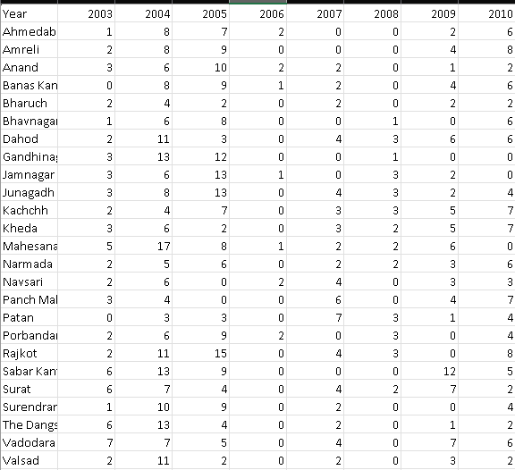

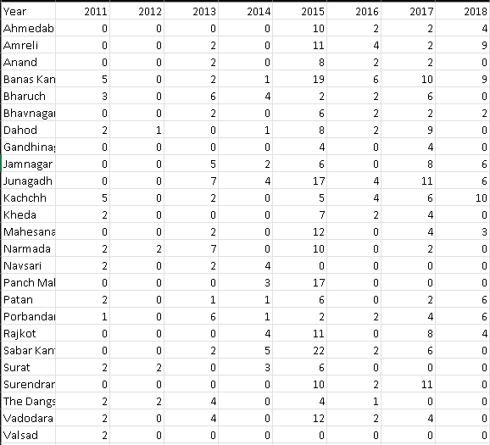

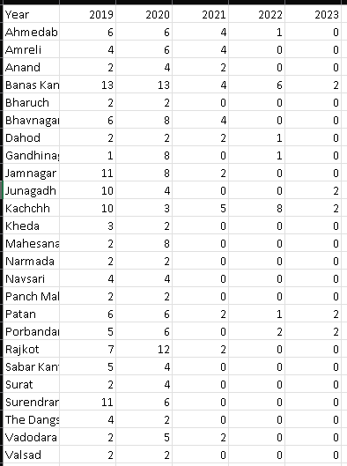

**References**

Adrian Piticar, Sorin Cheval, Maria Frighenciu, A review of recent studies on heat wave definitions, mechanisms, changes, and impact on mortality :

<https://www.researchgate.net/publication/342684820_A_review_of_recent_studies_on_heat_wave_definitions_mechanisms_changes_and_impact_on_mortality> .

Akhil Srivastava, M. Mohapatra & Naresh Kumar, Hot weather hazard analysis over India:

<https://www.nature.com/articles/s41598-022-24065-0> .

Amit Awasthi, Kirti Vishwakarma, Kanhu Charan Pattnayak, Retrospection of heatwave and heat index:<https://www.researchgate.net/publication/356134847_Retrospection_of_heatwave_and_heat_index> .

Partha Pratim Gogoi, V. Vinoj, D. Swain, G. Roberts, J. Dash & S. Tripathy, Land use and land cover change effect on surface temperature over Eastern India:

<https://www.nature.com/articles/s41598-019-45213-z> .

Parthkumar N. Parmar, Mehul R. Pandya, Jalpesh A. Dave, Hasmukh K. Varchand, Himanshu J. Trivedi, Heat Wave Study using Satellite LST and Air Temperature Data over Gujarat Region :\

<https://ieeexplore.ieee.org/document/10118491> .

Prabir Kumar Das, Ushashi Podder, Rituparna Das, Chandrasekar Kamalakannan, Goru Srinivasa Rao, & Soumya Bandyopadhyay & Uday Raj, Quantification of heat wave occurrences over the Indian region using long-term (1979–2017) daily gridded (0.5° × 0.5°) temperature data a combined heat wave index approach : <https://doi.org/10.1007/s00704-020-03329-7> .

Raju Mandal, Susmitha Joseph, A. K. Sahai, R. Phani, A. Dey, R. Chattopadhyay &D.R Pattanaik, Real time extended range prediction of heat waves over India:

<https://www.nature.com/articles/s41598-019-45430-6> .

Rani Devi, Krushna Chandra Gouda, Smrutishree Lenka, Analysis of heat wave over different physiographical regions in India : <https://link.springer.com/article/10.1007/s00704-023-04639-2#:~:text=Some%20key%20finding%20of%20this,northern)%20parts%20of%20the%20country>